TASK-10: Build a Student CRUD application using Spring Boot.

AIM: Build a Spring Boot application to perform CRUD (Create, Read, Update, Delete) operations on a Student1 table using JPA annotations.

ALGORITHM:
- Start the Spring Boot application
- Connect to MySQL database
- Receive HTTP request (POST/GET/PUT/DELETE)
- Controller handles the request
- Service processes business logic
- Repository interacts with database using JPA
- Perform Create / Read / Update / Delete operation
- Return response to client
- Stop

OUTPUT1: performing created operation
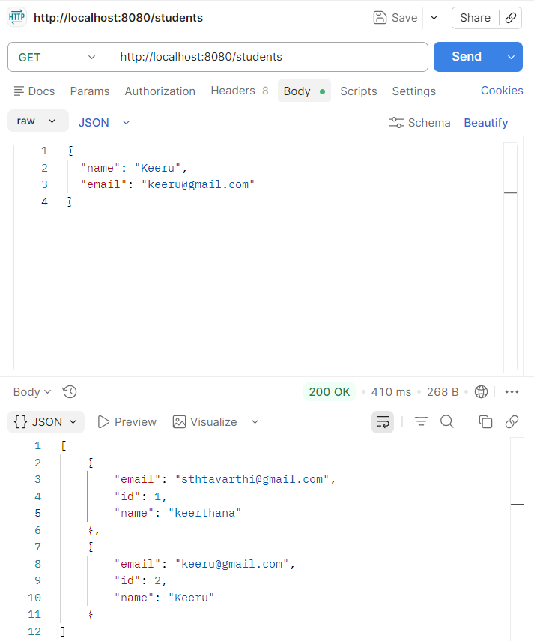

OUTPUT2: performing read operation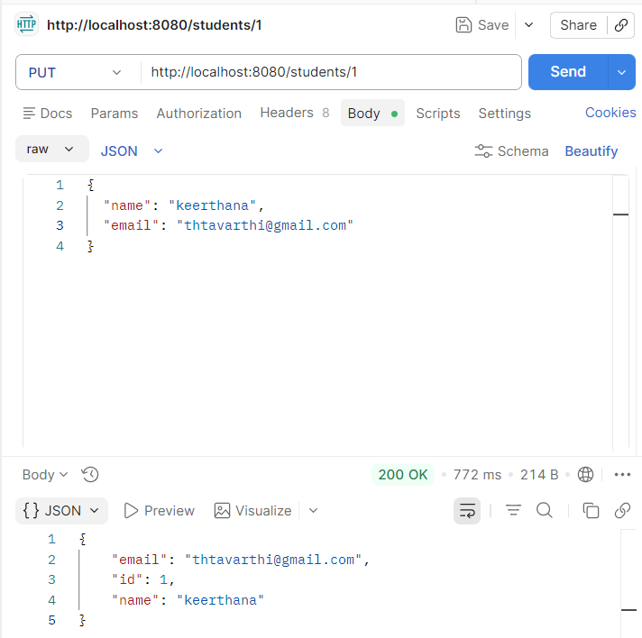

OUTPUT3: performing update operation


OUTPUT4: performing delete operation
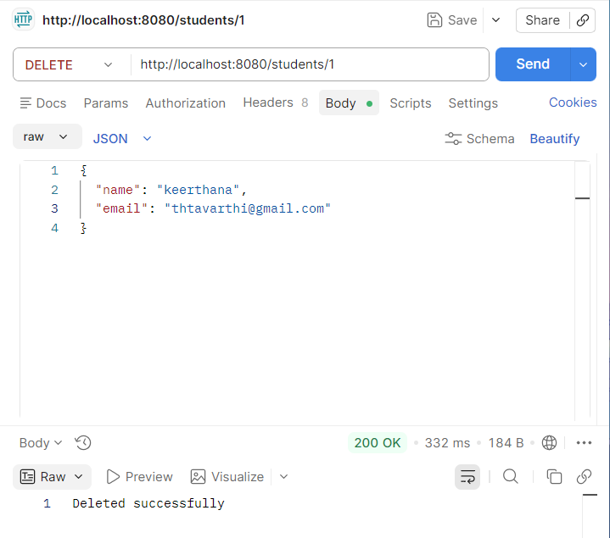
Result:
Student data is successfully stored, retrieved, updated, and deleted using REST APIs. The application runs correctly with Spring Boot and JPA connected to MySQL

